Hands on session
PLSQL Excerises
Exercise 1: Control Structures
Scenario 1: The bank wants to apply a discount to loan interest rates for customers above 60 years old.
  - Question: Write a PL/SQL block that loops through all customers, checks their age, and if they are above 60, apply a 1% discount to their current loan interest rates.
Scenario 2: A customer can be promoted to VIP status based on their balance.
  - Question: Write a PL/SQL block that iterates through all customers and sets a flag IsVIP to TRUE for those with a balance over $10,000.
Scenario 3: The bank wants to send reminders to customers whose loans are due within the next 30 days.
  - Question: Write a PL/SQL block that fetches all loans due in the next 30 days and prints a reminder message for each customer.
Objective
Perform conditional operations using loops and control structures based on business rules.
Steps to implement
- Step 1: Create Tables
- customers: Holds customer details like name, age, balance, VIP status
- loans: Holds loan details such as amount, interest rate, due date
- Step 2: Insert Sample Data
- Populate both table with realistic cutomer and loan information
- Step 3 : Scenario 1 – Age-Based Interest Discount
- For customers aged above 60, apply a 1% discount on their current loan interest rates.
- Step 4: Scenario 2 – VIP Based on Balance
- Set IsVIP = 1 for customers having balance > $10,000
- Step 5: Scenario 3 – Loan Due Reminders
- Send reminders for loans that are due within 30 days.
- Step 6: Commit Changes

Code

SET SERVEROUTPUT ON;
BEGIN EXECUTE IMMEDIATE 'DROP TABLE loans'; EXCEPTION WHEN OTHERS THEN NULL; END;

CREATE TABLE customers (
customer_id NUMBER PRIMARY KEY,
customer_name VARCHAR2(100),
age NUMBER,
balance NUMBER,
IsVIP NUMBER(1) DEFAULT 0
);

CREATE TABLE loans (
loan_id NUMBER PRIMARY KEY,
customer_id NUMBER REFERENCES customers(customer_id),
loan_amount NUMBER,
interest_rate NUMBER,
due_date DATE
);

INSERT INTO customers VALUES (1, 'John Smith', 65, 15000, 0);
INSERT INTO customers VALUES (2, 'Mary Johnson', 45, 8000, 0);
INSERT INTO customers VALUES (3, 'Robert Davis', 72, 25000, 0);
INSERT INTO customers VALUES (4, 'Sarah Wilson', 35, 12000, 0);
INSERT INTO customers VALUES (5, 'Michael Brown', 58, 5000, 0);
INSERT INTO customers VALUES (6, 'Lisa Anderson', 68, 18000, 0);

INSERT INTO loans VALUES (101, 1, 50000, 0.08, SYSDATE + 15);
INSERT INTO loans VALUES (102, 2, 30000, 0.09, SYSDATE + 45);
INSERT INTO loans VALUES (103, 3, 75000, 0.07, SYSDATE + 10);
INSERT INTO loans VALUES (104, 4, 40000, 0.085, SYSDATE + 60);
INSERT INTO loans VALUES (105, 5, 25000, 0.095, SYSDATE + 25);
INSERT INTO loans VALUES (106, 6, 60000, 0.075, SYSDATE + 5);

COMMIT;

-- Scenario 1: Apply 1% interest discount if age > 60
BEGIN
FOR rec IN (
SELECT c.customer_id, c.customer_name, c.age, l.loan_id, l.interest_rate
FROM customers c
JOIN loans l ON c.customer_id = l.customer_id
) LOOP
IF rec.age > 60 THEN
UPDATE loans
SET interest_rate = interest_rate - 0.01
WHERE loan_id = rec.loan_id;

DBMS_OUTPUT.PUT_LINE('Customer: ' || rec.customer_name ||
' | Age: ' || rec.age ||
' | Old Rate: ' || rec.interest_rate ||
' | New Rate: ' || (rec.interest_rate - 0.01));
END IF;
END LOOP;
COMMIT;
DBMS_OUTPUT.PUT_LINE('✅ Scenario 1 complete: Discount applied for customers above 60.');
END;
/

-- Scenario 2: Set VIP if balance > 10,000
BEGIN
FOR rec IN (SELECT customer_id, customer_name, balance FROM customers) LOOP
IF rec.balance > 10000 THEN
UPDATE customers
SET IsVIP = 1
WHERE customer_id = rec.customer_id;

DBMS_OUTPUT.PUT_LINE('Customer: ' || rec.customer_name ||
' | Balance: ' || rec.balance ||
' | VIP: TRUE');
END IF;
END LOOP;
COMMIT;
DBMS_OUTPUT.PUT_LINE('✅ Scenario 2 complete: VIP status updated.');
END;
/

-- Scenario 3: Reminders for loans due in next 30 days
DECLARE
v_reminder_count NUMBER := 0;
BEGIN
FOR rec IN (
SELECT c.customer_name, l.loan_id, l.due_date, l.loan_amount
FROM customers c
JOIN loans l ON c.customer_id = l.customer_id
WHERE l.due_date BETWEEN SYSDATE AND SYSDATE + 30
) LOOP
v_reminder_count := v_reminder_count + 1;
DBMS_OUTPUT.PUT_LINE('🔔 Reminder ' || v_reminder_count || ': ' ||
rec.customer_name || ' has Loan ID ' || rec.loan_id ||
' due on ' || TO_CHAR(rec.due_date, 'DD-MON-YYYY') ||
' | Amount: ' || rec.loan_amount);
END LOOP;

IF v_reminder_count = 0 THEN
DBMS_OUTPUT.PUT_LINE('✅ No loans due in next 30 days.');
ELSE
DBMS_OUTPUT.PUT_LINE('✅ Scenario 3 complete: Total reminders sent = ' || v_reminder_count);
END IF;
END;
/

Output
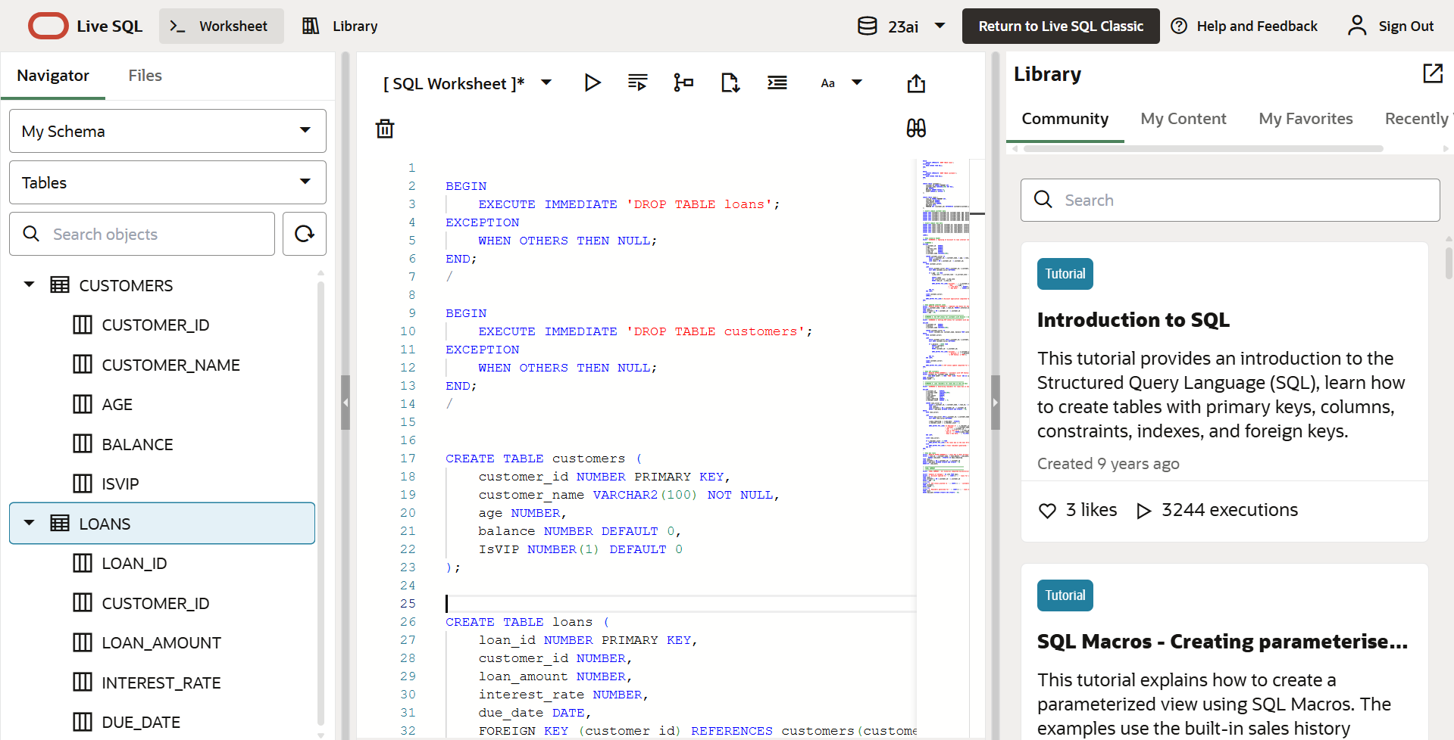

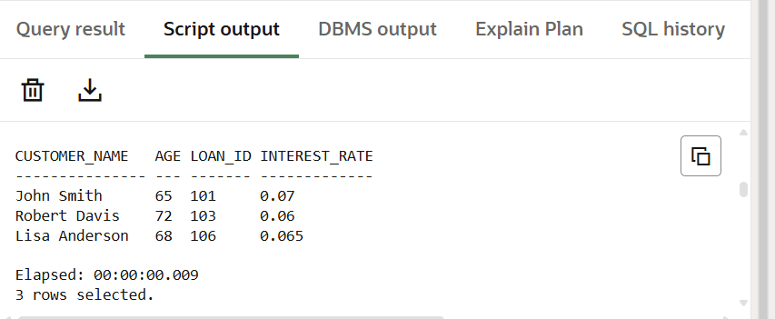
Scenario 1
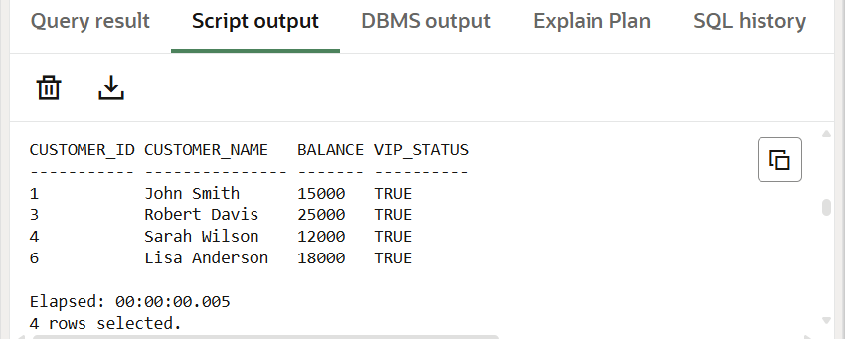
Scenario 2

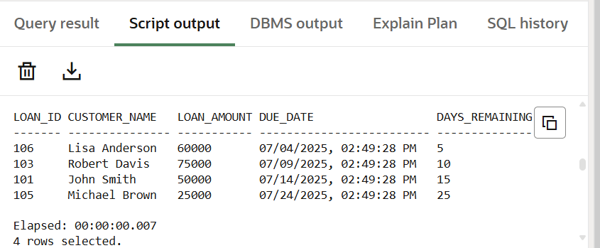

Scenario 3

